|  |  |
| --- | --- |
| Recipient |  |
| Cc |  |

|  |  |
| --- | --- |
| Topic | **CAN BOARD PRACTICE – DIAGNOSTIC COMMUNICATION** |

**Requirements specification**

# Benefit

After this practice, students will understand and have experience on Diagnostic UDS-ISO14229. This Diagnostic standard is supported by most of ECUs in Automotive nowadays.

Students able to implement the most important Diagnostic services ($27 - Security access; $22-ReadDataByIdentifier and $2E- WriteDataByIdentifier)

Students also have knowledge and can implement CAN_TP layer in Transport protocol layer based on CAN protocol. The main purpose is to send and receive more than 8 bytes of data.

Also, students will get familiar with Diagnostic specification that is closely with actual project.

# System Overview

The system includes 2 CAN boards with difference role: 1 diagnostic tester (Tester) and 1 ECU.

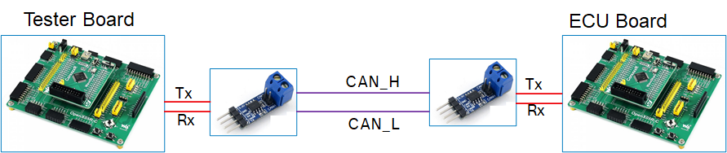

The 2 boards can perform diagnostic communication via CAN protocol.

Below picture depicts difference layers. The detail specification of each layer in following session of this document.

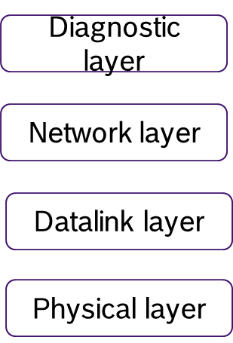

# Physical Layer

The physical layer shall fulfil with the requirements of ISO11898-2/5.

The diagnostic communication speed is the same as application communication speed.

# Data link Layer

The data link layer shall fulfil with the requirements of ISO11898-1.

The CAN DLC contained in every diagnostic CAN frame transmitted by ECU shall always be set to eight (8) bytes. To avoid bit padding, the unused data bytes of a CAN frame shall be padded with 55h.

ECU can receive diagnostic CAN frame with a DLC less than eight (8) which is send by Tester.

# Network layer

## Addressing Method

This specification requires that the ECU only supports normal addressing, and therefore 11 bit CAN identifiers shall be used.

Only physical addressing shall be supported by ECU. Functional addressing not needs to be supported.

## Diagnostic CAN ID

Request Id: 0x712

Response Id: 0x7A2

Tester send request via Request Id to ECU. Then ECU response the request by Response Id.

## Diagnostic Message Format

The CAN message frame format is described in the following table. For detailed definition, please refer CAN_TP documentation or the training material.

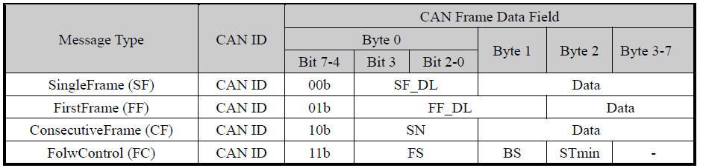

## Parameters Definition

The parameters and workflow of network layer are defined in the following figure and table. For detailed definition, please refer CAN_TP documentation.

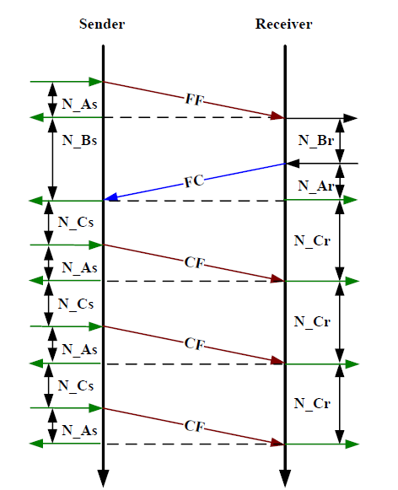

When multi-message required, Sender and Receiver will communicate based on above flow chart.

The Maximum number of ‘FC.Wait frame transmissions’ (N_WFTmax) shall be set to zero (0). Therefore it is not allowed to use FC.Wait.

The Block Size and Separation time (ms) are defined as below:

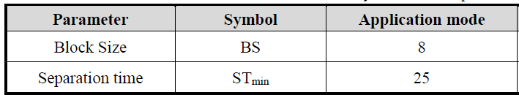

In the scope of this practice, it is not required to implement below Network layer timing parameters. This is for your reference purpose only. In real project, these timing parameters need to be implemented properly.

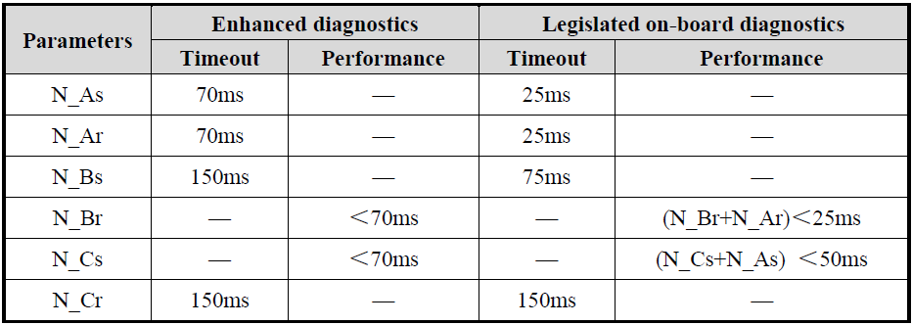

# Diagnostic layer

## Common specification

### Timing requirement

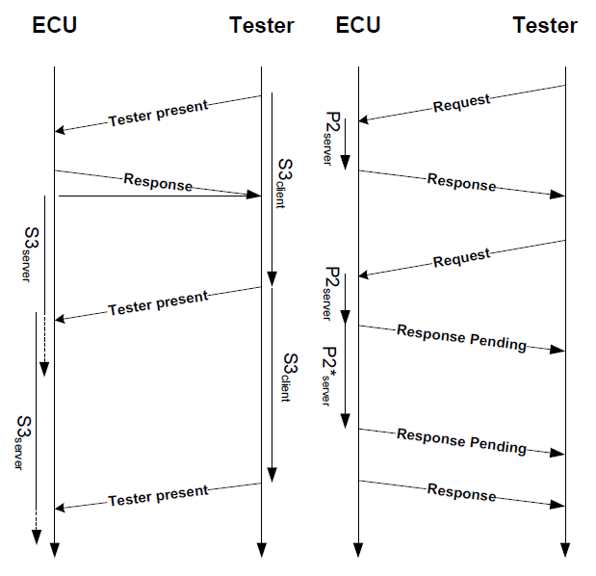

Above picture shows diagnostic layer timing between Tester and ECU. Tester will request and ECU will response based on the request contain.

The parameters of diagnostic layer are defined in the following figure and table.

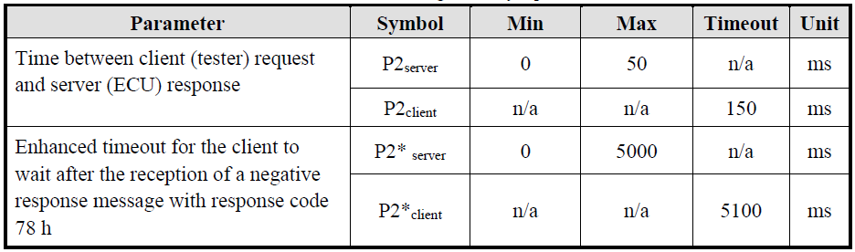

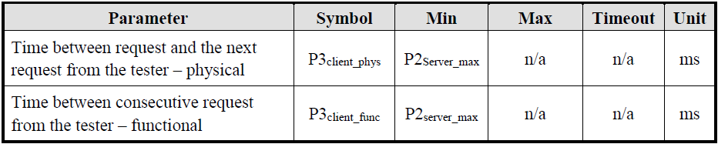

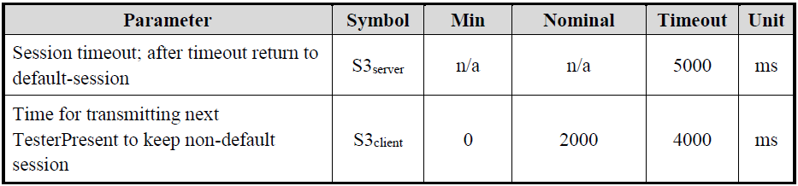

To reduce the complexity of this Diagnostic practice, it is not required to implement above diagnostic parameters.

### Diagnostic Services

The chapter defines the diagnostic services and implementation rules.

The following table shows all the UDS diagnostic services. The list has been sorted according to the Service Identifier (SID) assigned to each diagnostic service.

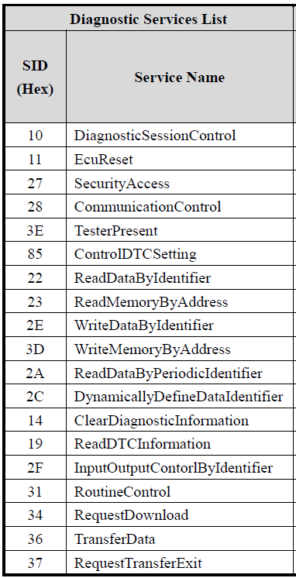

suppressPositveResponseBit (SPRS) is not required for this practice.

### Negative Response Code (NRC)

It is not required to implement NRC for this practice. Instead of response NRC, the ECU keep silent and not response anything.

In real project, the ECU need to support many differences NRC based on UDS-14229 standard. NRC helps to diagnose problem quickly.

### Diagnostic session

Typically, all ECUs will support below 3 diagnostic sessions. However, these sessions also not in the scope of this practice.

* Default session.
* ProgrammingSession
* ExtendedDiagnosticSession

## ReadDataByIdentifier (22h)

The request message requests data record values from the ECU identified by DataIdentifier.

The ECU sends data record values via the positive response message. The format and definition of the RecordValues is defined in separate document. RecordValues shall include analogue input and output signals, digital input and output signals, internal data and system status information if supported by the ECU.

### Message Format:

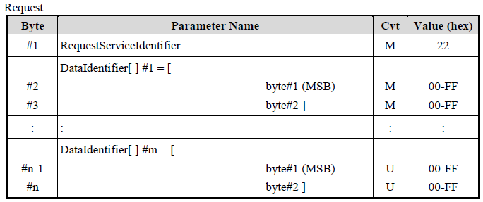

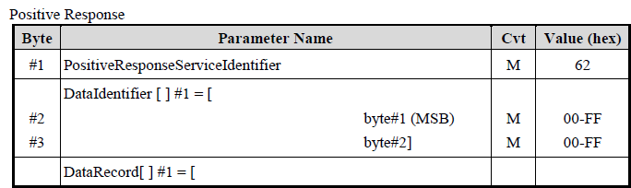

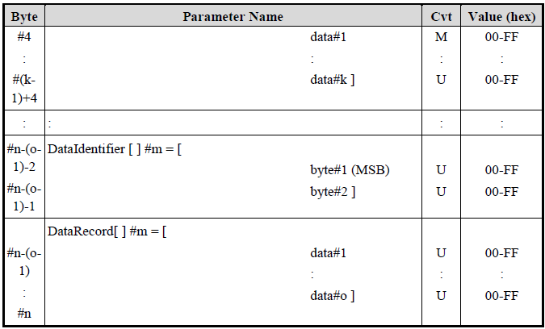

The maximum number of data identifiers to be read within a single request is limited to 1.

## SecurityAccess (27h)

The SecurityAccess service is used to provide a means to access data and/or diagnostic services, which have restricted access for security, emissions, or safety reasons. Diagnostic services for downloading/uploading routines or data into a ECU and reading specific memory locations from a ECU are situations where security access may be required. Improper routines or data downloaded into a ECU could potentially damage the electronics or other vehicle components or risk the vehicle’s compliance to emission, safety, or security standards.

The security access concept uses a seed and key algorithm. For the first step, the tester shall request the ECU to unlock by sending the service SecurityAccess - RequestSeed message.

The ECU shall respond by sending a seed using the service SecurityAccess - RequestSeed positive response message. The seed is the input parameter for tester and ECU to calculate the corresponding key value.

For the second step, the tester shall request by returning a key number back to the ECU using SecurityAccess - SendKey message. The ECU shall compare this key to one internally stored/calculated value. If the two numbers match, then the ECU shall enable (unlock) the tester’s access to specific services/data and indicate that with the service SecurityAccess - SendKey positive response message. If the two numbers do not match, this shall be considered as a false access attempt. If access is rejected for any other reason, it shall not be considered as a false access attempt. An invalid key requires the tester to start over from the beginning with a SecurityAccess - RequestSeed message. The procedure of Send and Key algorithm is showed in following figure.

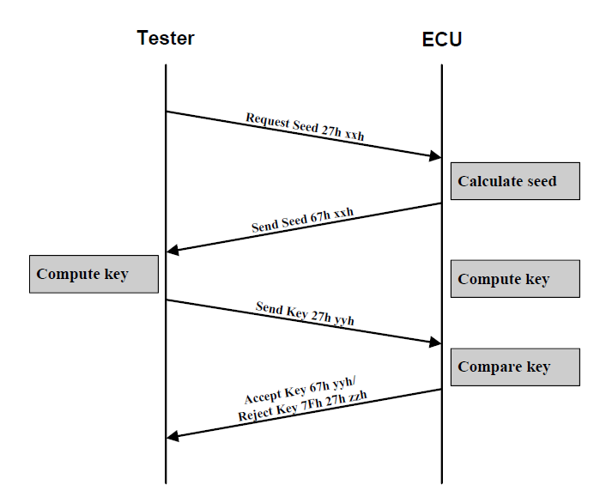

### Message Format - Request Seed

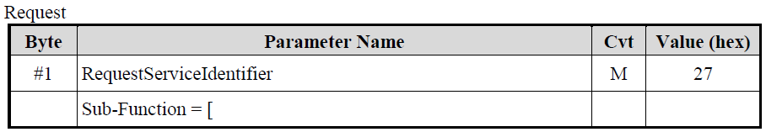

Positive response:

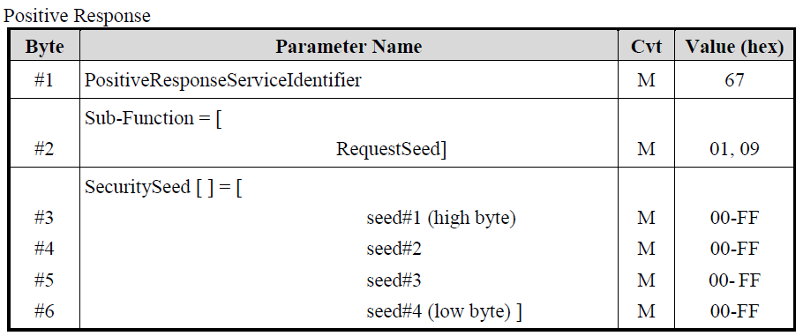

### Message Format – Send Key

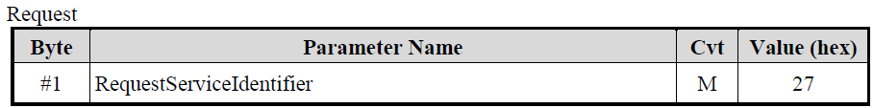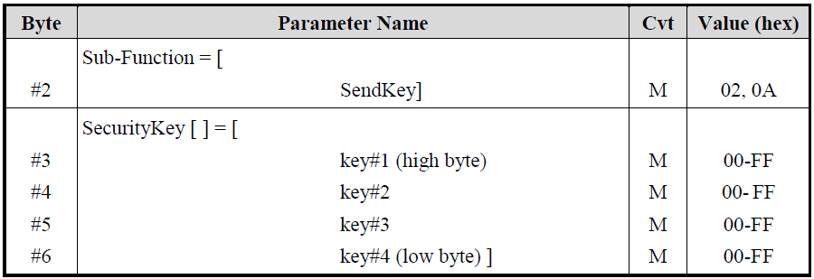

Positive Response:

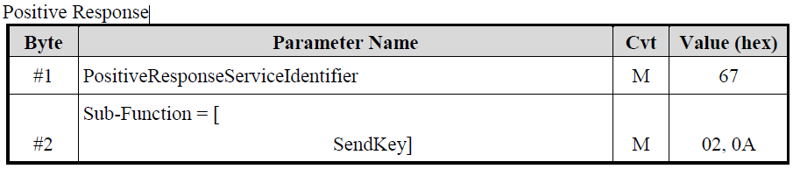

The SecuritySeed and SecurityKey are both 4 bytes (32 bits) number. The security access algorithms of each level would be defined and described in a specific file.

The SecuritySeed is a random number except for two value 00000000h and FFFFFFFFh.

Only one security level shall be active at any instant of time.

If the tester sends an invalid key, the request is rejected by ECU and insert 10s delay before it can receive and process next seed request.

## WriteDataByIdentifier (2E)

The WriteDataByIdentifier service allows the tester to write information into the ECU at an internal location specified by the provided data identifier. Possible use-cases for this service are:

* Programming configuration information (e.g. VIN).
* Resetting learned values.
* Setting option content.
* Enable or disable function.

### Message Format

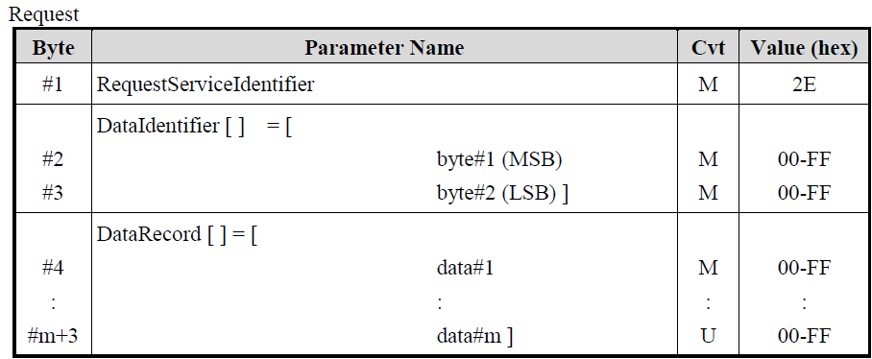

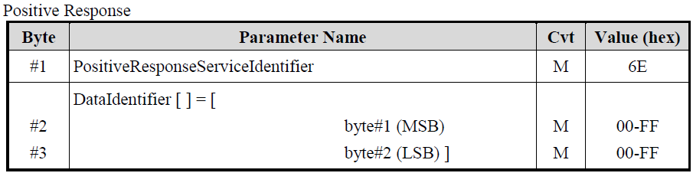

### Implementation Rules

Only one (1) dataIdentifier which is supported by the ECU shall be included in the request message.

# Practice list

## Practice 1 specification

In this practice, student will implement service $22 - Read Data by Identifier to read and display ADC value on LCD.

Tester board will send request to ECU board read ADC value.

ECU board receives request, convert ADC and response back current ADC value.

Tester board receives ADC value from ECU board response and then show the value on LCD.

Tester board will send request to read ADC value for each 1 second.

Data ID: 0xF001

DID length: 3 bytes.

Format: Binary.

## Practice 2 specification

In this practice, student will implement $2E- WriteDataByIdentifier service to write a mount of data into ECU. ECU will responses and display values on LCD.

Based on which Joystick button position is pressed in tester board, tester board will send request to ECU board to write the corresponding data. Note that the data is not enough to process with one single frame. Then required to process with multi-message method (CAN_TP).

ECU board receives request, display full receive data on LCD.

Data ID: 0xF002

DID length: 6 bytes.

Format: Binary.

|  |  |
| --- | --- |
| Pressed Joystick position | Data (Hex) |
| Middle | 00 00 00 00 00 00 |
| Left | AA AA AA AA AA AA |
| Right | FF FF FF FF FF FF |

## Practice 3 specification

In this practice, student will implement $27 - Security access service to unlock the ECU.

Tester board will send seed request and key to the ECU board.

ECU board will response seed and check if received key is correct. If received key is correct, then ECU will response positive, change from Locked to Unlock state and turn on any LED to indicate that ECU is now in Unlock state.

Tester board will start sending seed request and unlock process when a button is pressed.

In ECU board, LED is off when ECU in Locked state. LED is on when ECU in Unlock state. By default, ECU board will be in Locked state.

Sub-service: 0x01 - Request Seed L1.

0x02 - Send Key L1.

Seed length: 4 bytes (S12 S34 S56 S78)

Seed algorithm: random number

Key length: 4 bytes

Key algorithm: K12 K34 K56 K78: (K12=S12+1) (K34=S34+1) (K56=S56+1) (K78= S78+1)

# Output and evaluation

## Expected output

* Requirement analysis: despite how student understand requirement. What tasks need to be done.
* OPL (Open point list) file: all of student’s doubts as well as answers will be documented in this file.
* Design document: describe how your program is structure.
* Code: to evaluate clean code
* Test spec, test result, test log: follow the template here



* Presentation document on process and result.

## Evaluation

* Functionality: follow defined test cases.
* Requirement analysis: how well requirement was analysed.
* Design: how well design is.
* Clean code
* Test: how well of test case.
* Oscilloscope (from Osc picture -> decode to contains of CAN frame)